**Financial Time Series Project**

**Question**: Assume the data file contains the observations of a time series variable $z_{t}$ each month from January 2011 to February 2019. The variable $z_{t}$ is created for you to practice your time series analysis skills. You can imagine $z_{t}$ as the monthly price of a certain commodity. Assume the data is linear and has no seasonality. Import the data into R, fit the data into an appropriate linear univariate time series model (AR, MA, or ARMA), and conduct the point forecast and interval forecast of $z_{t}$ for the future 8 months (March, April, May, June, July, August, September, October of 2019). Also use the theoretical formula to conduct the point forecast of $z_{t}$ for the future 2 months (March and April of 2019) and see if they are the same as the results produced by the functions of R. Please submit a Word document, which shows your R codes and the results from R for every step. You can use snipping tool to screenshot the results from R for every step, copy and paste them on the Word document.

The deadline of the project submission is 11:59 pm on March 1, 2019. Please submit your completed project through the Canvas.

**Step 1:** **Read data into R**

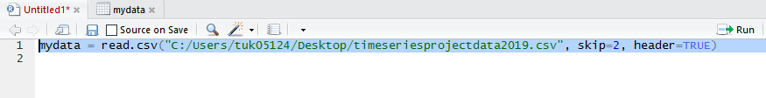



**Draw the scatter plot of data**

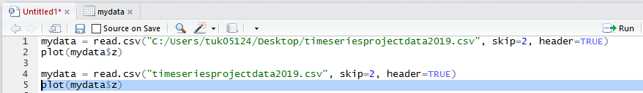

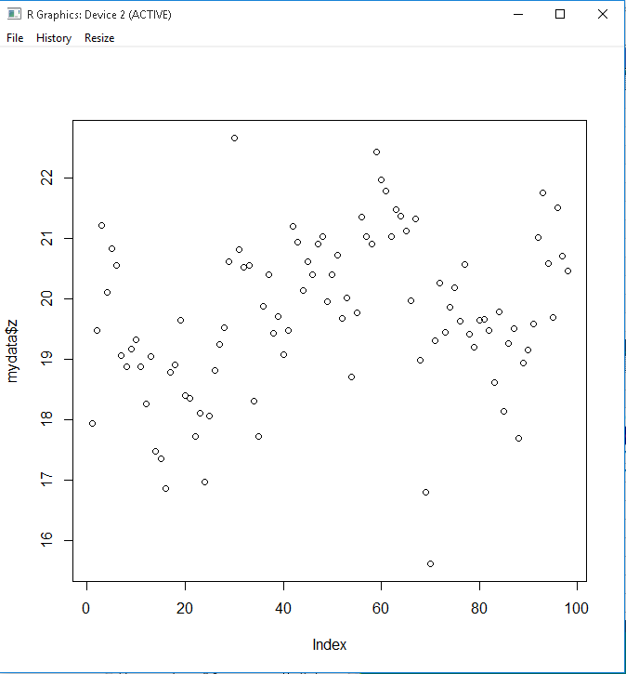

**Step 2:** **Tell R that the data is the time series data**

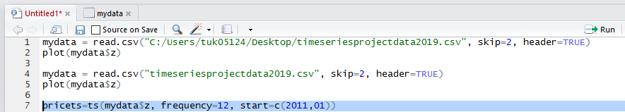

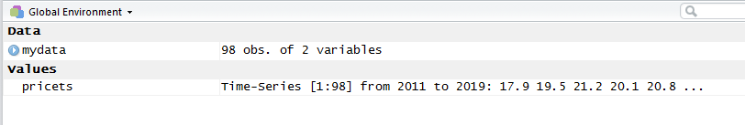**Check**

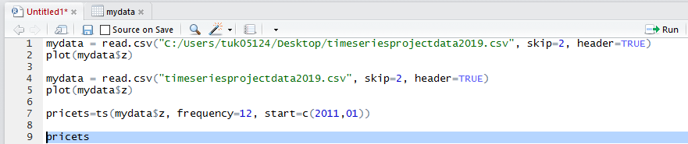

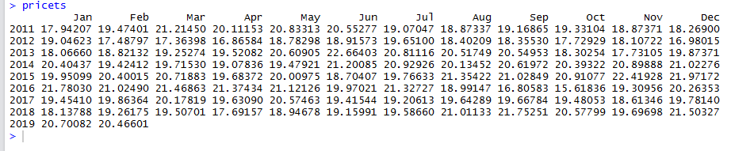

**Plot(pricets)**

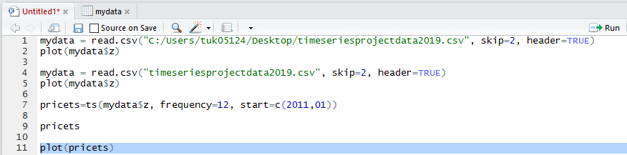

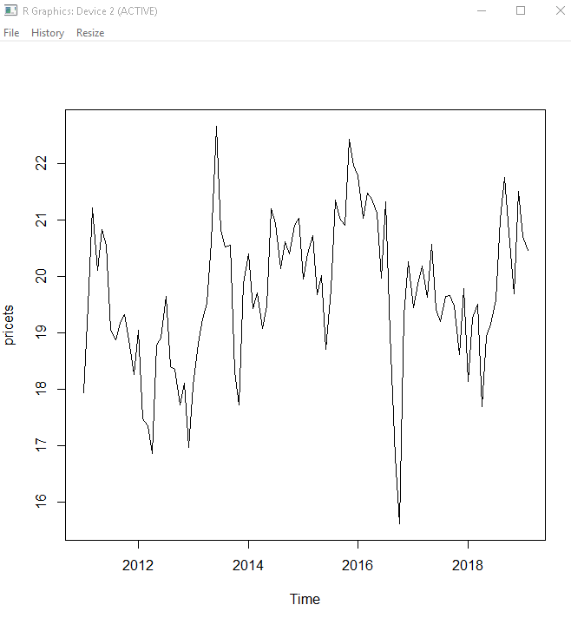

**Step 3: determine if the data is stationary or not by using informal methods**

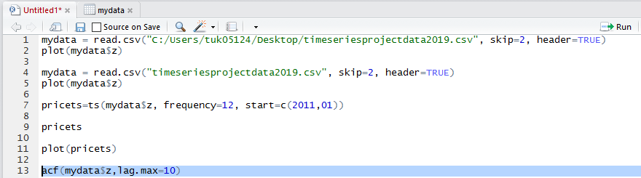

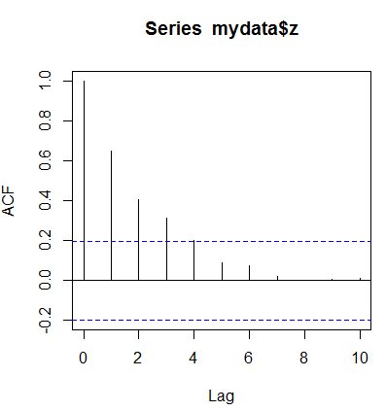

**The ACF decays gradually, and not all equal to 1. Hence the data can be stationary.**

**Step 4: determine if the data is stationary or not by using formal methods (unit root test)**

We use the Augmented Dickey-Fuller (ADF) test for unit root test.

∆𝑦𝑡 = 𝛽0 + 𝜏𝑦𝑡−1 + 𝛽1∆𝑦𝑡−1 + 𝛽2∆𝑦𝑡−2 + ⋯ +𝛽𝑘∆𝑦𝑡−𝑘 + 𝑢𝑡

The null hypothesis and the alternative hypothesis are 𝐻0: 𝜏 = 0 (i.e. the model is unit-root nonstationary)

and 𝐻𝐴: 𝜏 < 0 (i.e. the model is stationary). The ADF test is a one-sided test. We compare the t-statistic of

𝛽 with the critical value to make the rejection decision.

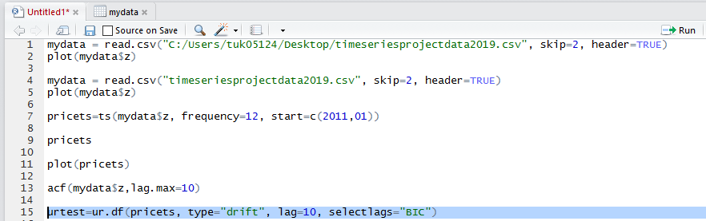

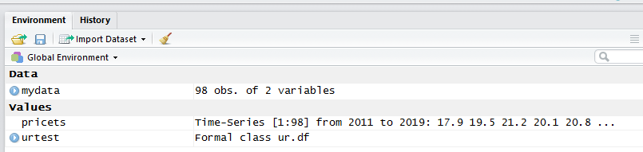

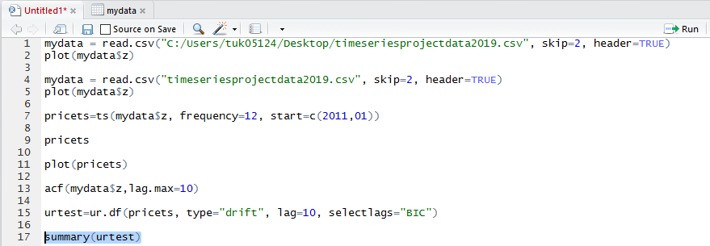 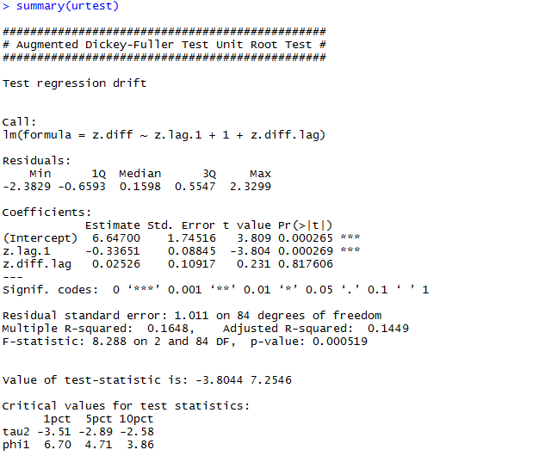

Based on the ADF unit root test result, the BIC determines that the model has 1 lag. 𝜏 = −0.33651, which is negative. The t-statistic of 𝜏 is less than those critical values, indicating that alternative hypothesis is true, 𝜏 is negative and the data is stationary.

**Step 5: fit the stationary data into the appropriate univariate time series model.**

The standard for AR model, MA model, and ARMA model.

For AR(k) model, ACF decays gradually, and PACF cuts off at lag k.

For MA(q) model, ACF cuts off at lag k, and PACF decays gradually.

For ARMA(k,q) model, both ACF and PACF decays gradually. No cut off.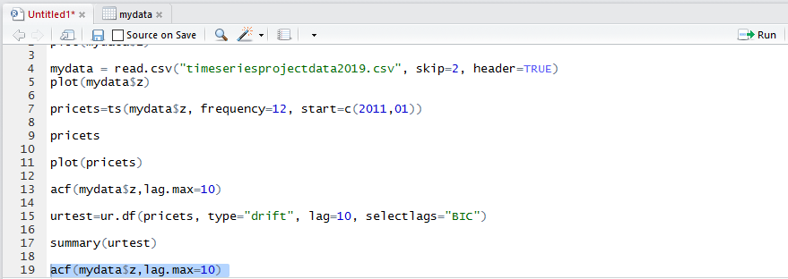 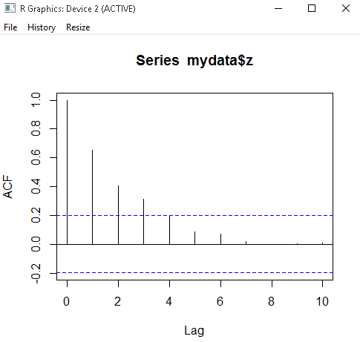

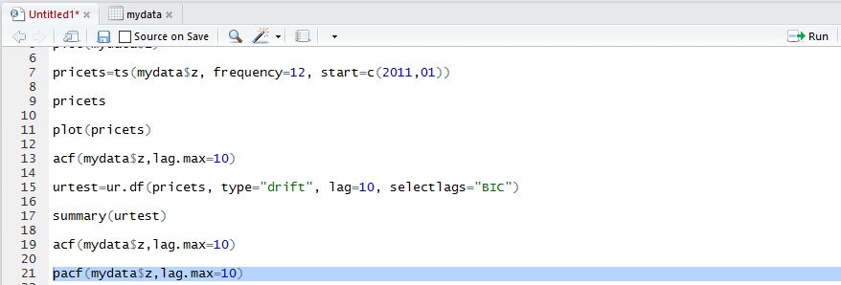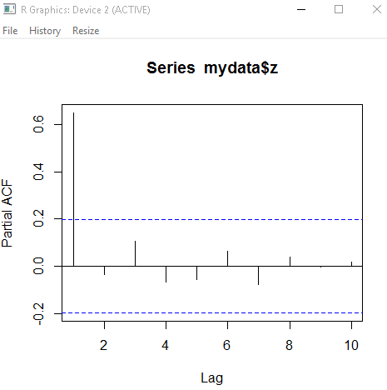

The ACF decays gradually and PACF cuts off at lag 1, so the model should be AR(1).

$$y_{t}= ϕ_{0}+ϕ_{1}y_{t-1}+u_{t}$$

**Step 6. Formally estimate the parameters of AR(1) model, 𝜙0 and 𝜙1**

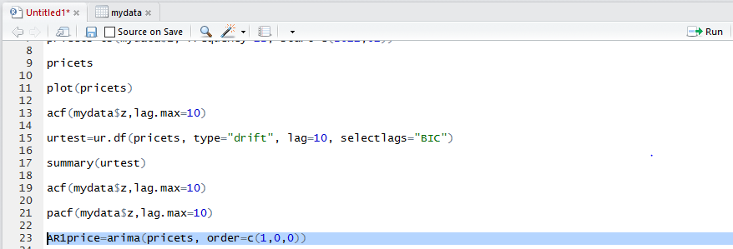 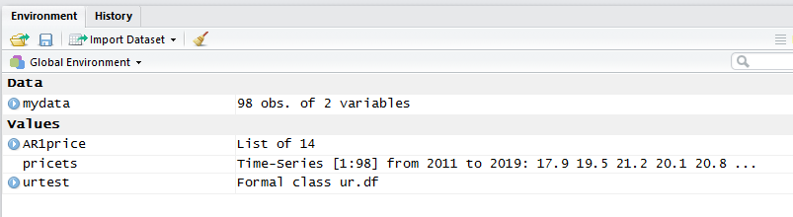

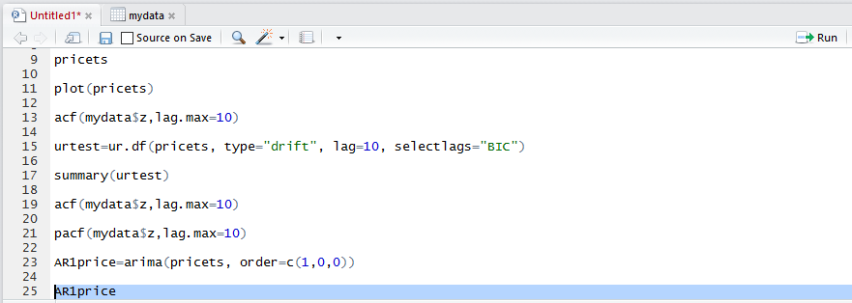

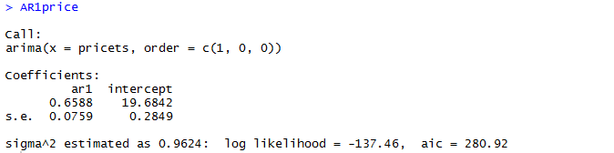

First, 𝜙1 = 0.6588

Second, 𝜙0 ≠ 19.6842. Please notice that 19.6842 is not the value of intercept of AR(1) model. 19.6842 is the mean of the data. 𝜇 = 19.6842. This is a mistake made by R.

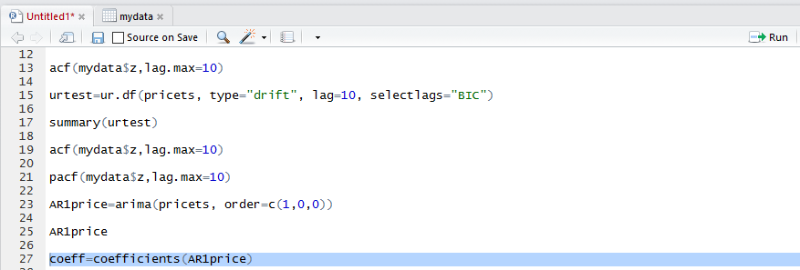

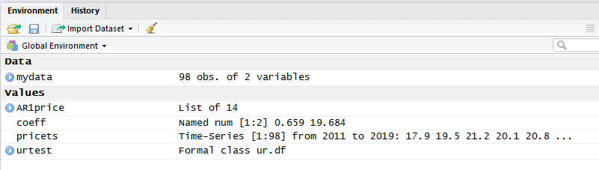

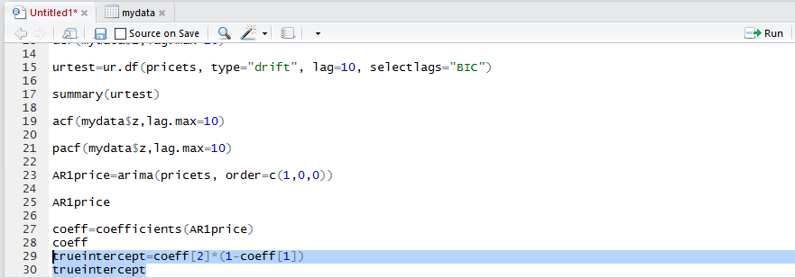



This 6.716494 is the correct value for the AR(1) intercept $ϕ_{0}$.

$ϕ_{0}$ = 6.716494.

The AR(1) model is estimated as following:

$$y_{t}= ϕ_{0}+ϕ_{1}y_{t-1}+u_{t}$$

$$y_{t}= 6.716494+0.6588y_{t-1}+u_{t}$$

**Step 7: check the adequacy of the fitted model**

If the fitted AR(1) model $y_{t}= 6.716494+0.6588y_{t-1}+u_{t}$ is adequate, the residual series 𝑢𝑡 should be a white noise. A white noise has no autocorrelation.

Method 1: check the ACF of the residual 𝑢𝑡 . If all the ACF starting from lag 1 are 0, then we can conclude the residual 𝑢𝑡 has no autocorrelation, and the fitted model is adequate.

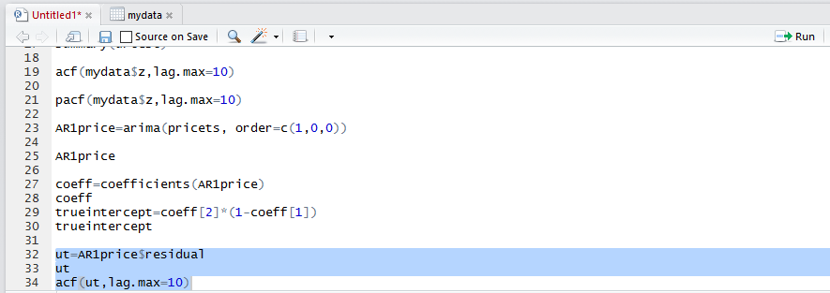

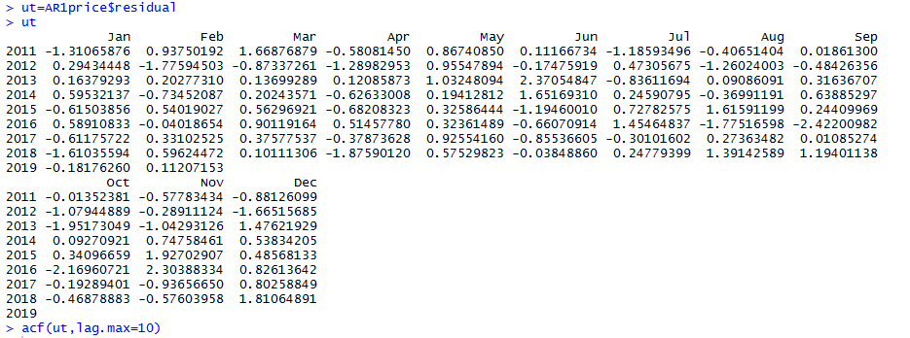

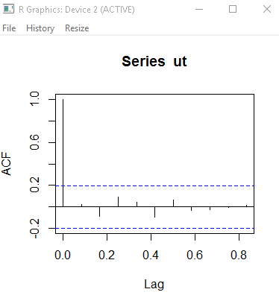

Based on the ACF graph, all the ACF starting from lag 1 are all equal to 0. Hence the residual term 𝑢𝑡 has no autocorrelation and hence it is a white noise. The fitted AR(1) model $y_{t}= 6.716494+0.6588y_{t-1}+u_{t}$ is adequate.

**Step 8: conduct point forecast for the future 6 months**

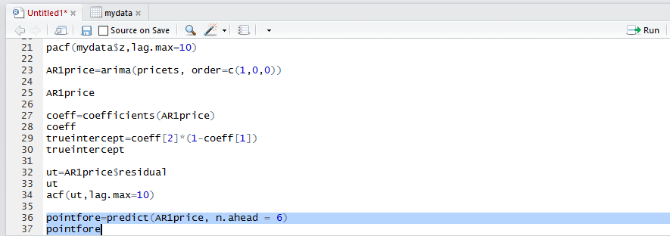

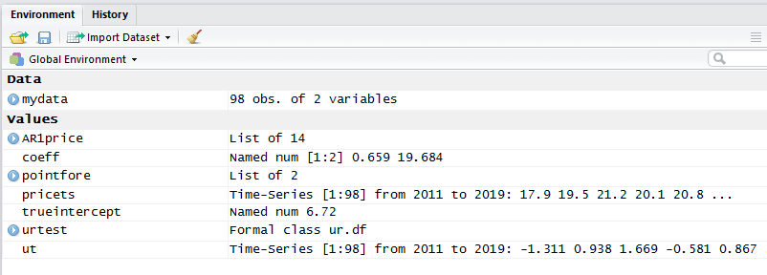

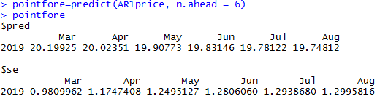

R prediction function predicts that the future price in March is 20.19925, the future price in April is 20.02351, the future price in May is 19.90773, the future price in June is 19.83146, the future price in July is 19.78122, the future price in August is 19.74812.

**Using the theoretical formula to calculate the prediction:**

**1-step ahead point forecast of $y_{h+1} is {ŷ}_{h}\left(1\right)=ϕ_{0}+ϕ_{1}y_{h}$**

$ϕ_{0}$ is the true intercept calculated in step 6.

$ϕ_{1 }$ is the ar1 parameter estimated in step 6.

$y_{h}$ is the last observation of original data set, which is the price in February 2019.

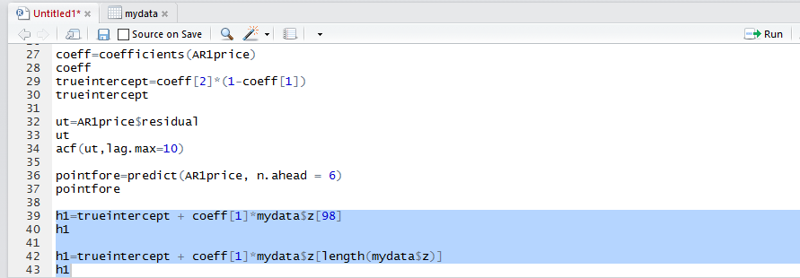

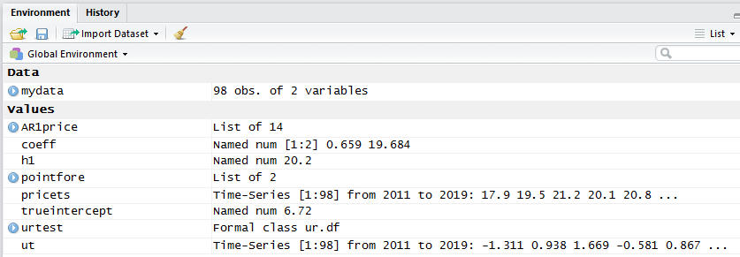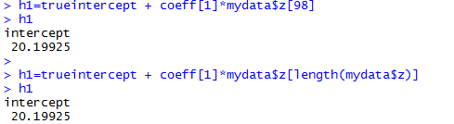

The forecasted result of March price is exactly the same as that of prediction function. This also confirms that $ϕ_{0}$ ≠ 19.6842, 𝜇 = 19.6842, and $ϕ_{0}$ = 6.716494.

**2-step ahead point forecast of $y_{h+2}$ is**

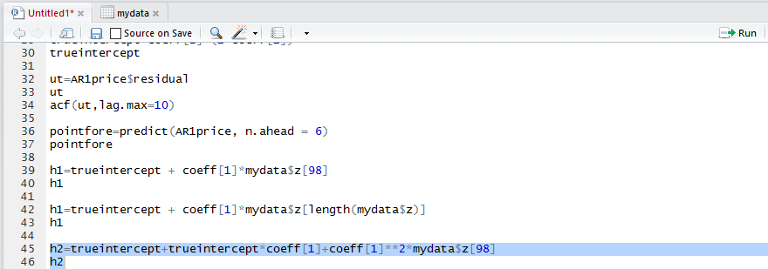

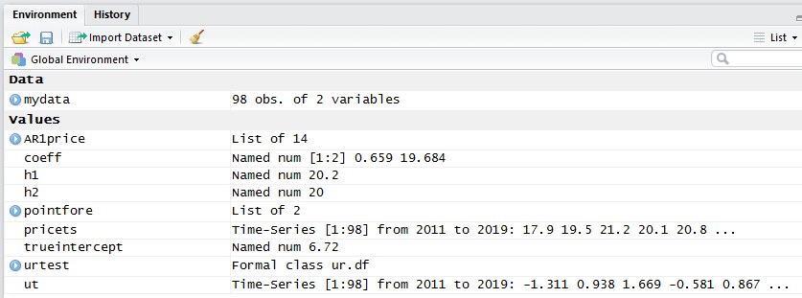



The forecasted result of April price is exactly the same as that of prediction function.

**Step 9: conduct interval forecast for the future 6 months**

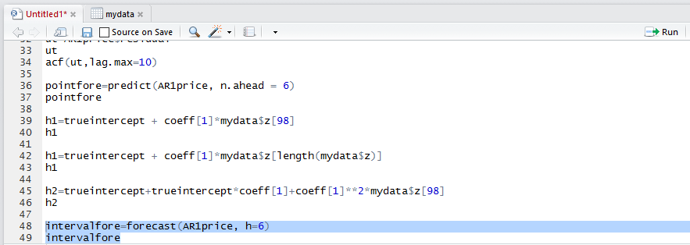

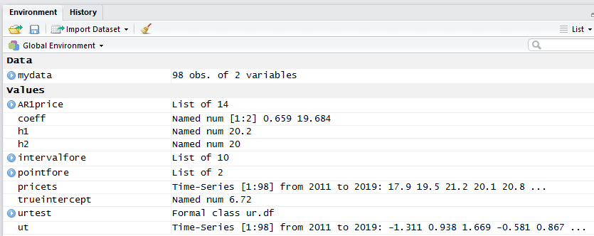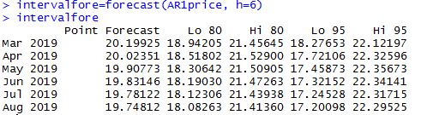

The more step ahead forecast, the less accurate, which means a larger forecast error variance and a larger forecast interval.